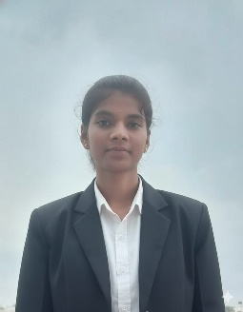
PRIYADHARSHINI S
Contact No: +917358421126
Email ID: dharshinikumar106@gmail.com
CAREER | OBJECTIVE
To secure a challenging position in a reputed organization where I can apply my analytical, communication, and people-management skills to contribute to organizational growth while continuously improving my technical knowledge and professional abilities. I am detail-oriented, dedicated to accuracy, and driven by a passion for learning and making sound decisions.
ACADEMIC | PROFILE
Course | Institution | Board/University | Year | Percentage
10th (SSLC) | St. Claret Hr.Sec School | State Board | 2020 | All Pass
12th (HSC) | St. Claret Hr.Sec School | State Board | 2022 | 69%
B.E CSE(AIML) | Sethu Institute of Technology | Anna University | 2023-2027 | 7.6

TECHNICAL | SKILLS
Programming languages : C,C++,Java, Python.
Front-end : HTML ,JavaScript, CSS, React
Design Tools : Canva, Figma
Software Tools : GitHub , Android Studio
ACADAMIC | ROJECTS
Title: AI-Based Smart School Bus Floor Safety Monitoring System.
Description: Developed an AI-enabled safety system using pressure sensors and machine learning to detect damaged or weak bus floor areas in real-time and send instant alerts to prevent child accidents.
INTERNSHIP
Completed Basic Robotics Training on as part of an internship through the e-Yantra Lab Setup Initiative at Sethu Institute of Technology, Madurai and by the ZetsPire Technologies Pvt. Ltd., Madurai.(09/12/2024 – 17/12/202)

AREA | OF | INTERESTS
- Full Stack Development
- UI/UX Design
- Cloud Computing.

ACHIEVEMENTS
- Completed a course on “Introduction to Industry 4.0 and Industrial of Things” in NPTEL
- Completed a course on Java Development
- Completed a course on Front-end Development
EXTRA | CURRICULAR
- Member of NSS
- Member of Initiative Club
KEY | STRENGTH
- Flexibility and Adaptability
- Creating a positive work environment
- Problem Solver
- Ability to learn
HOBBIES
- listening music.
- Gardening.
PERSONAL | DETAILS
Name | : Priyadharshini
Father name | : Selvakumar
Date of birth | : 26/11/2005
Gender | : Female
Marital status | : Single
Nationality | : India
Language known : Tamil, English
DECLARATION
I here by declare that all the information mentioned above is true to my knowledge and I bear the
responsibility for the above mentioned particulars.

SIGNATURE
S.Priyadharshini

